|  |  |
| --- | --- |
| **Orienteering**  **Measuring Widths** | C:\Users\james\OneDrive\BSA\Woodbadge\Project\EEE Flag Color.JPG |

**The Compass Method**

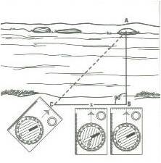

**The Salute Method**

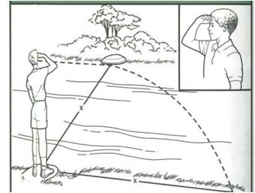

**Pacing**

Pacing is a type of measurement using the size of the steps your take. To find your pace lay the 100ft of rope out straight on the ground. Choose an end to start from, and begin walking with your left foot starting. Count how many times your right food hits the ground until you reach the other end of the rope. Take the number of steps and divide it by 100. This will calculate your pace. (100 / 20 steps = 5ft)

**Salute Method**

The Salute Method allows you to measure the width of an object, such as the width of a river. To do this, stand on one side of the river and locate an object on the bank of the other side. Salute and adjust your line of sight so your right hand is on the opposite side of the river. Once this is done turn your body 90 degrees. Make a note of where your right hand is now touching the ground. Pace out the distance from where you are standing to where your hand appears to touch the ground. This will give you the width of the river or other object.

**The Compass Method**

The Compass Method allows you to use some basic math to find the width of an object, such as a river. To begin find an object on the opposite side of the river. Get out your compass and point the direction of travel arrow at the object. Turn the bezel to 45 degrees, and begin walking to your left until the magnetic needle is boxed within the orienteering arrow. Once this is done pace from that point back to your starting point to find the width.

**Equipment:**

* 100ft of Rope
* 4 Sticks
* Compass

**Object:** Teach how to measure the widths of objects without using a tape measure.

**The Stick Method**

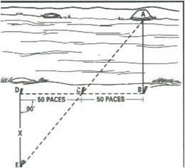

**The Stick Method**

The Stick Method is a more accurate way to determine the width of an object, such as a river. To begin, stand on one side of the river and locate an object on the opposite side of the river (A). Place a stick directly opposite the object on the other side of the river (B). Turn 90 degrees to the left and walk 50 paces. Place a stick in the ground at this point (C). Continue walking another 50 paces from that stick, and place a stick at the final point (D). If there is not room to do 50 paces, you may adjust the paces to fit your area just make sure you use the same number of paces. From your last stick turn 90 degrees so your back is to the river or object. Walk straight until you can draw a line from the original object (A) through the middle stick (C) to where you are standing (E). Pace the distance from where you are standing back to the sick behind you (D).